**ONLINE BANKING**

Project By: **Abdur Rehman Aziz**Seat no **: B20102009**

You have to run “banking.py” file. (“banking_func.py” only contains functions related to the project)

When you run the program it’ll ask you to specify your account type i.e. either “***admin***” or “**user**”.

Usernames and Pins are given in “.***csv files***” . Close all the .csv files before running the program, otherwise it’ll give you a **PERMISSIONERROR** b/c it can’t write lines while the csv files are open.

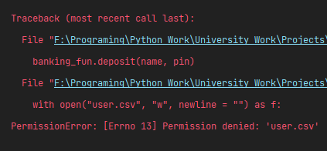

If you enter incorrect Username it’ll end the program by printing the message “***Account haven't found.***” . Similarly by entering the wrong Pin 3 times it’ll end the program by printing the program “***Please try again later***”.

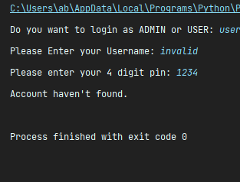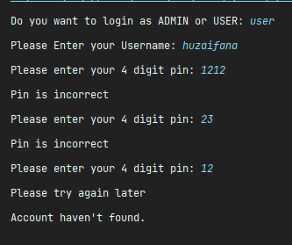

1. **LOGIN AS USER :**

When you login you’ll see multiple transactions you can do. To select an option you must enter the number written on the left side of the transaction. After each transaction, program will keep asking if you want to make another transaction or not. You only have to type “***Y***” or “***N***”.

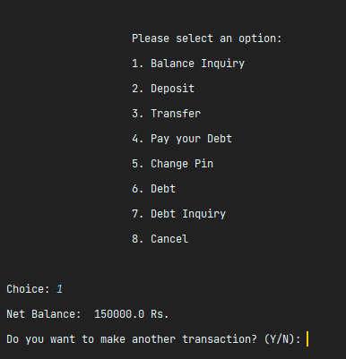

While doing the ***TRANSFER***, the program will ask if the person, whom you are sending the amount, is whether in the same bank or not. If yes, type "s" (same); if not, type "d" (different). Then it'll ask you the Account No. and Username of the person. In the case of an account in the same bank, the program will check if such a person has an account in this bank or not. If yes, the amount will be deducted from your account and will be added to that person's account; if not, no amount will be deducted and it'll print a message "***Account haven't found***."

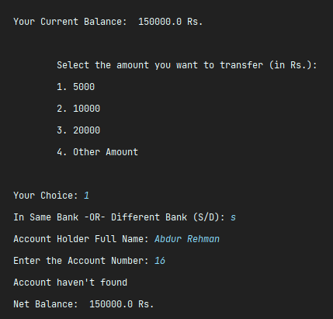

Whereas, in the case of an account in a different bank, the amount will be deducted without checking the person's id.

While applying for ***DEBT***, keep in mind that you are eligible for debt ***IF AND ONLY IF*** the debt amount for which you are applying is less than 20% of your current balance or you don’t have previous debt greater than the 5% of your current balance, otherwise, you won’t get the debt (It’s a little bit confusing, but I hope you understood it correctly).

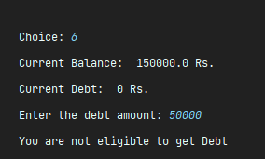

While paying debt if you accidentally pay amount greater than the current debt, you don’t need to worry about it. The only amount equal to your debt will be deducted and the rest will be added to your balance.

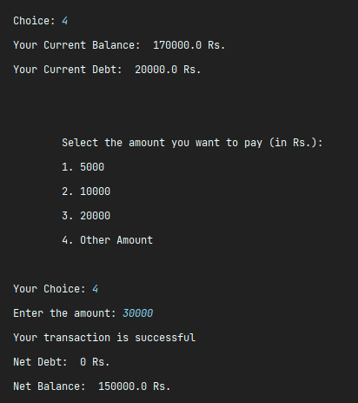

1. **LOGIN AS ADMIN :**

When you login you’ll see multiple transactions you can do. To select an option you must enter the number written on the left side of the transaction. After each transaction, program will keep asking if you want to make another transaction or not. You only have to type “***Y***” or “***N***”. (Just like in the case of User).

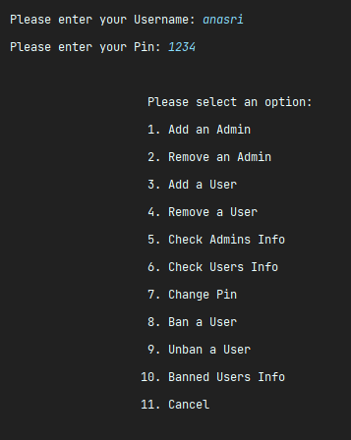

Only ***MANAGER*** is allowed to ***ADD*** or ***REMOVE*** other admins, and to see the Usernames of other admins in ***CHECK ADMINS INFO*** which helps in removing admins. However, any Admin can ***ADD***, ***REMOVE*** or ***BAN USERS*** and also see see User and Admin Data (except their Usernames).

If you ***REMOVE USERS***, their account will get permanently deleted unless you ***ADD*** him again, of course. But, if you ***BAN USERS*** for any reason, you can ***UNBAN*** them anytime you want without losing their info of them.

When ***ADDING USER***, if you select an **ACCOUNT NO**. or **USERNAME** that is already taken by a User, the program will keep asking you to enter the Account No or Username until you assign a unique Username or Account No. But you can assign the assign the Account No. of a user whose Account is ***REMOVED*** or deleted.

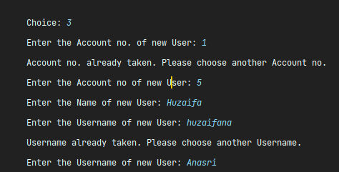

There are few other options as well. But I haven’t mentioned them in this documentation because they are not so complicated.

I hope you like my project. If you find some difficulty, problem, or mistake by any chance, please do let me know and also please guide me.  
  
  
 **Thank You So Much.**